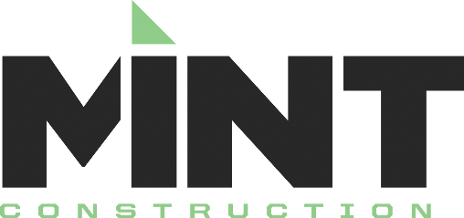

Recommendations to follow to ensure prompt payment.

- Make sure your W9 has been submitted to Mint construction.
- Make sure your contractor’s license is up to date and a current copy is submitted to Mint Construction.
- Submit your pay application with its accompanied schedule of values on or before the date stipulated in your contract. (Please use the forms as directed by Mint’s Project Manager.)
- Make sure your “Supplier Affidavit” has been returned to Mint Construction. If you do not have a supplier, note that on the Affidavit.
- With each pay application, submit lien waivers from all your suppliers covering the period of the pay application.
- Make sure any outstanding change orders have been signed and returned to Mint Construction.
- Make sure the following insurance certificates are current and have been submitted to Mint Construction:
  - General Liability, along with a copy of the “Additional Insured Endorsement” which is a separate form from the certificate of liability insurance.
  - Automobile
  - Worker’s Compensation
  - Excess Liability

Supplier lien waivers will be required before a payment is processed. Once Mint has received all supplier lien waivers, payment will be processed and a Mint lien waiver(s) will be e-mailed to you. Please sign and return it as soon as possible. Once the lien waiver(s) has been signed and returned, and Mint’s accounting department has the items listed above, your check will be mailed or available for you to pick up.

Submit these items to accounting@buildwithmint.com

